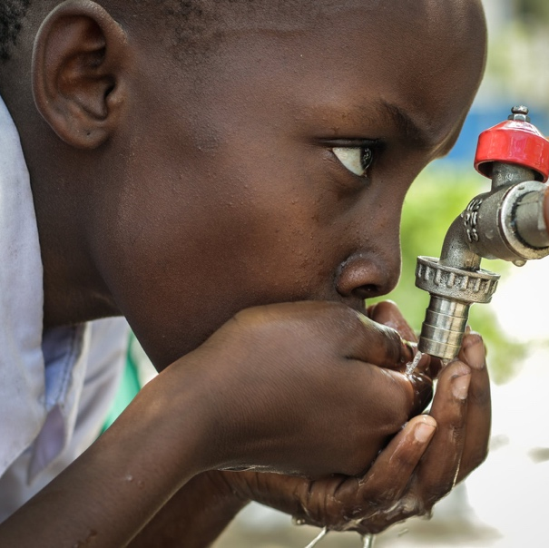
APPLICATION FORM

HENRI BOULARD
AWARD
2024
MICROBIOTA & ENVIRONMENTAL CONCERNS
PLEASE COMPLETE THIS FORM AND SEND IT BACK BY EMAIL TO:
apply@biocodexmicrobiotafoundation.com
HENRI BOULARD AWARD – 2024
APPLICATION FORM
Information Notice
BIOCODEX MICROBIOTA FOUNDATION, a company foundation for microbiota founded by BIOCODEX (hereafter referred to as the “Foundation”), whose headquarters are located at 7 Avenue Gallieni in GENTILLY (94250), France, has implemented a processing of personal data to support international research projects on microbiota and human health.
This processing is required for the legitimate interests of the Foundation (promoting research on microbiota and their interaction with different pathologies).
By submitting your application, you authorize the Foundation to process your data confidentially and securely, within the strict framework of the above-mentioned processing. Your data will be kept from the time of receipt until the award winner is selected, then they will be permanently archived. However, should you be the award winner, your data will be kept on an active database for the duration of the research project (3 years maximum), then for another 3 years (given the tax authorities’ prescription periods).
Within the limits of their requirements, the recipients of all or part of your data will include the members of the Foundation’s board and international scientific committee, BIOCODEX staff members responsible for the administrative management of the Foundation and staff of any service providers involved.
Due to the international nature of this competition, certain data are liable to be transferred outside the European Union. According to the applicable regulation concerning personal data protection, particularly Regulation (EU) 2016/679 dated April 27, 2016 (General Data Protection Regulation), you can exercise, upon proof of your identity, a right of access, a right to rectification, to erasure, to restriction and to object regarding data relating to you by contacting BIOCODEX’s Data Protection Officer (DPO), in English or French, by e-mail (dpo@biocodex.com) or by mail (DPO BIOCODEX, 7 Avenue Gallieni, 94250 GENTILLY, France). You can also, if necessary, submit a complaint to a supervisory authority (the CNIL for France – www.cnil.fr).

Document to be completed for application:
1. Project leader information □
2. Project leader CV □
3. Application form completed: Project description, etc □
4. Timelines grid □
5. Estimated budget □
6. Quotation of the budget (if applicable) □
7. Bank account details (personal bank details are not allowed) □
8. Authorisation to publish the project and photos on BMF □

Please note that an incomplete dossier will not be evaluated

1. Project leader information

PROJECT LEADER

FIRST NAME*:
LAST NAME*:
POSITION*:
TITLE*:
MAIN DISCIPLINE*:
TELEPHONE*:
CELL PHONE*:
E-MAIL*:
CV: attach file to your email (2 pages including best or last publications) see part 4

ORGANIZATION
NAME*:
LEGAL STATUS*:
SERVICE*:
STREET ADDRESS 1*:
STREET ADDRESS 2*:
CITY*:
ZIP/POSTAL CODE*:
COUNTRY*:

OTHER ORGANIZATION INVOLVED IF RELEVANT

NAME*:
JURIDIC STATUS*:
STREET ADDRESS 1*:
STREET ADDRESS 2*:
CITY*:
ZIP/POSTAL CODE*:
COUNTRY*:

2. Project leader CV (Resume can be joined)

Title, Name
Professional address
Graduation
Postgraduate training
Recent work or research activity
Publication
Honors and awards (if any)
Community involvement
Professional affiliation

3. Application form completed

PROJECT SUMMARY
(1 page, Arial 10)

ITEM | TO BE COMPLETED
Title of the project

Location of the project

Persons involved in the project
(number, position, title)

Duration
of the project
Other comments

PROJECT DESCRIPTION
(3 pages, Arial 10)

What is the general context of the project ?

What are the project’s objectives?

How does the project respond to a locally unmet needs for human health?

What is the project’s methodology (i.e. tools used to measure efficacy) ?

What are the expected results?

How will the project be deployed?

Any necessary administrative authorization: attach the file to your email

4. Timelines
DESCRIPTION | START | END (if relevant)
Project conception
Budget definition
Funding sponsor
Material acquisition
Human resources
(if needed)
Project set up
Project start
Project follow up
Project end
Project analysis
Project report
If other items are necessary, please insert them

5. Estimated budget
(1 page, Arial 10)

6. Bank account details ( personal bank details are not allowed)

7. Publication authorization

I, the undersigned, Dr ____________________________, declare my acceptance of the publication of the photos and project description for which I received the Biocodex Microbiota Foundation grant.

Dr ………
Date / /
Signature

